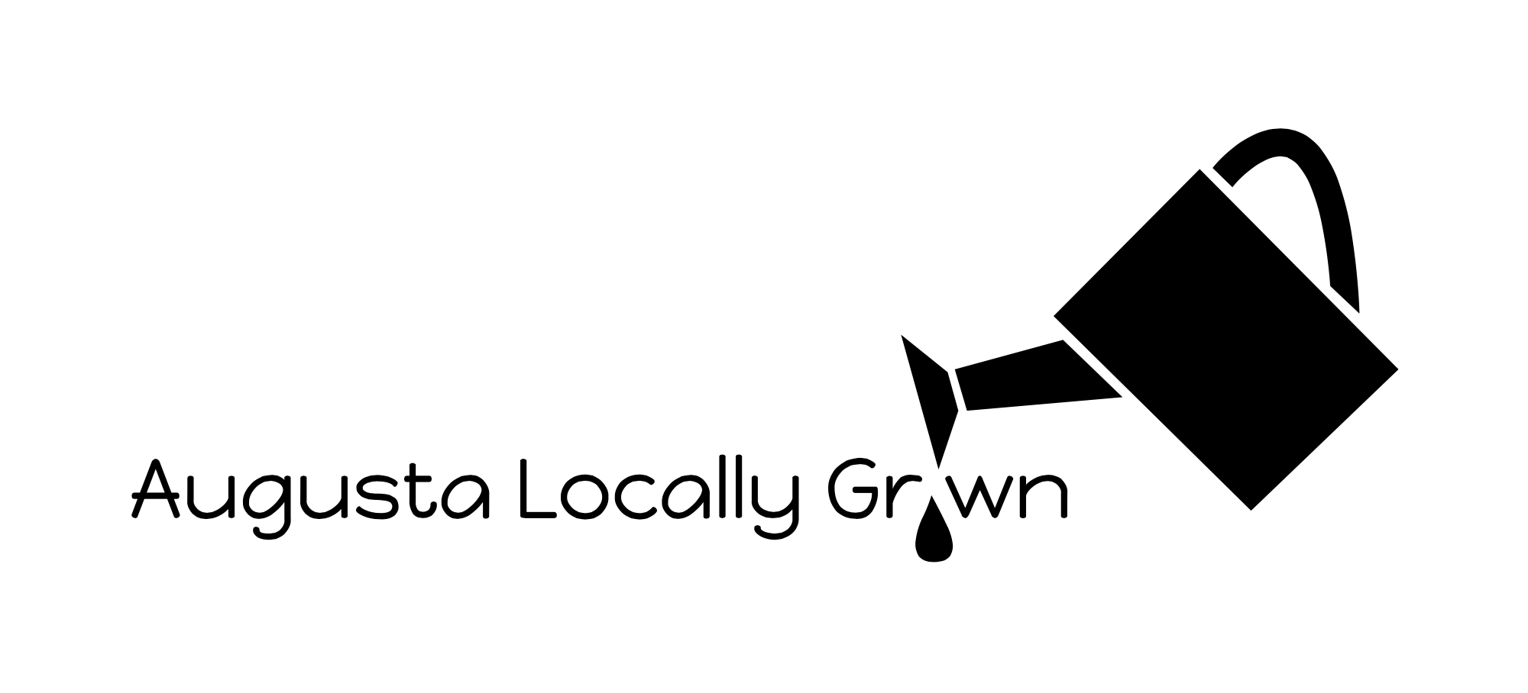

GROWER HANDBOOK

OUR PRIORITY:
Augusta Locally Grown is a 501c3 nonprofit organization. Our mission is to educate the public about the health, social, environmental and economic benefits of growing and eating local, naturally-grown foods. We aim to grow the local foods movement throughout the Central Savannah River Area. As such, one of ALG’s activities is to create and manage farmers markets that connect the community to local, seasonal, sustainable-grown food sold directly from producers to consumers. This includes (but is not limited to) the Augusta Locally Grown On-Line Market, the Evans Towne Farmers Market, the Veggie Truck Farmers Market and special events. All “growers” are required to abide by the guidelines of this handbook.

DEFINITION OF GROWER:
A farmer, maker of prepared foods, or maker of healthy living products is defined as a ‘Grower’ in this handbook.

DEFINITION OF LOCAL:
Local is defined as any item grown or made within 100 miles of the CSRA.

DEFINITION OF NATURAL/SUSTAINABLE:
Augusta Locally Grown expects all its Growers to practice sustainable methods suitable for their industry. Sustainable is defined as practices that follow and exceed organic standards as is possible within our region.
Farmers: standards can be found at:
- Certified Organic usda.gov
- Certified Naturally Grown naturallygrown.org
- Certified Humane certifiedhumane.org
Healthy Living Products: Only natural ingredients should be used in the making of healthy living products; avoiding such things as preservatives, synthetic fragrances, petroleum products, genetically modified products, etc.

DEFINITION OF DIRECT, PRODUCER-ONLY MARKET:
Augusta Locally Grown manages producer-only markets. NO wholesale brokers are allowed. All AUGUSTA LOCALLY GROWN Growers must be the primary grower/maker of the items being sold.

PROPER LABELING REQUIREMENTS:
Augusta Locally Grown expects all its Growers to adhere to state and federal labeling requirements.
These standards can be found at
Prepared Foods:
Cottage Industry Labeling:
http://agr.georgia.gov/Data/Sites/1/media/ag_consumerprotection/cottage_food/files/cottagefoodregulations.pdf
Healthy Living Products:
FDA Cosmetic Labeling:
http://www.ecfr.gov/cgi-bin/retrieveECFR?gp=&SID=4da126c5694eef0a5cd74856313d645e&n=21y7.0.1.2.11&r=PART&ty=HTML

LOCALLY GROWN INGREDIENTS:
Prepared Foods: Processed foods, such as jams and baked goods, must include some locally grown ingredients. In as much, products used should be sustainable and minimally refined.
Healthy Living Products: Locally grown ingredients for healthy living products are not always available; i.e. shea butter & rose hip seed oil. In as much, products used should be sustainable and minimally refined.

LICENSES AND CERTIFICATIONS:
Copies of legally required licenses and certifications must be submitted to AUGUSTA LOCALLY GROWN at the beginning of each year, or when the grower joins one or more of our markets.
STARTING IN 2016, all produce growers (fruits, vegetables and herbs) will be required to be certified: either as USDA Certified Organic or as Certified Naturally Grown. Each approved new grower that joins the organization after January 2016 will have 1 year to work toward certification if needed. ALG leadership will offer support and networking for growers working toward certification. Once ALG has taken this two-year step toward required certification for produce growers, it will consider certification for meat and dairy farmers. For 2015, minimum standards for meat and dairy farmers are those that meet and exceed the standards provided by Certified Humane.

LIABILITY INSURANCE & INDEMNIFICATION/HOLD HARMLESS PROVISIONS:
Participating vendors are encouraged to maintain product liability insurance. We ask that you also list Augusta Locally Grown as an “additional insured” on such policies. The policy should also cover incidents that may occur off your property related to the markets in which you participate. In 2015, insurance is not required but highly recommended.
By signing on as an AUGUSTA LOCALLY GROWN Grower, you agree to indemnify and hold harmless Augusta Locally Grown for actions occurring in connection with any/all of its markets.

HANDBOOK ENFORCEMENT:
The director of AUGUSTA LOCALLY GROWN is responsible for enforcing the rules of this handbook. The Board of Directors oversees the director and reviews cases in which a dispute or infringement occurs. In such cases, the Board may suspend a Grower from participating.

SITE VISITS:
All AUGUSTA LOCALLY GROWN Growers agree to a site visit, at any time, by a member of the board and/or the director. Visitors will use guidelines from Certified Naturally Grown or Certified Humane to access growing practices.

SALES & income TAX:
AUGUSTA LOCALLY GROWN is a manager of farmers markets. It is NOT a retailer or re-seller. Therefore, all AUGUSTA LOCALLY GROWN Growers are responsible for their own sales taxes.
For more information on how to obtain a Sales Tax Certificate of Registration and how to pay your sales tax, go to this link: http://online-tax-id-number.org/memdocs/state-sales-tax-applications/Georgia-State-Resale-Certificate-Application-Registration.htm
Growers are also responsible for reporting their own income for tax purposes.

REFUNDS & CREDITS:
Growers are responsible for handling cases of dissatisfaction directly with their market customers. AUGUSTA LOCALLY GROWN may help to enable communication, and growers may ask AUGUSTA LOCALLY GROWN to issue a refund or credit or other resolve for a customer (at the grower’s expense), but only after the grower has communicated directly with the customer about the issue.

SHARED COMMITMENT:
As a 501c3 nonprofit organization, Augusta Locally Grown relies on all participants to help promote its programs as well as the purpose by which it serves the community.

FARMER CHECKLIST
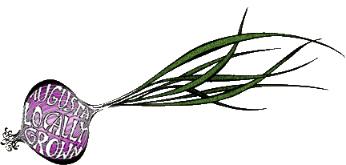
Name of Business:

Please check all that apply.
I have read and agree to abide by the rules of the Augusta Locally Grown Handbook.
I have attached copies of legally required licenses and certificates that apply to my particular agricultural industry.
__ Cottage Industry Certification __ Mobile Meat License
__ Live Plant License __ Egg Candling License
__ USDA Certificate for Acidified Foods __ Cheese Facility Certificate
__ Fertilizer License __ Hort Growing Media Registration
__ Soil Amendment Registration __ Other _________________

I have attached a copy of other certifications.
__ USDA Certified Organic
__ Certified Naturally Grown
__ Certified Humane
__ Other _____________________________________________

I am aware that sales and income reporting for tax purposes are my responsibilities as a Grower.
I have attached a copy of my product liability insurance, with Augusta Locally Grown listed as “additional insured.” (optional but highly encouraged)
By signing on as an AUGUSTA LOCALLY GROWN Grower, I agree to indemnify and hold harmless Augusta Locally Grown for actions occurring in connection with any of its markets or events.

Signed:
Print Name: |  | Date:

PREPARED FOODS CHECKLIST
Name of Business:

Please check all that apply.
I have read and agree to abide by the rules of the Augusta Locally Grown Prepared Foods Handbook.
I am aware that sales and income reporting for tax purposes are my responsibilities as a Grower.
I have attached a copy of my product liability insurance, with Augusta Locally Grown listed as “additional insured.” (optional but highly encouraged)
By signing on as an AUGUSTA LOCALLY GROWN Farmer/Grower, I agree to indemnify and hold harmless Augusta Locally Grown for actions occurring in connection with any of its markets or events.

Signed:
Print Name: |  | Date:

HEALTHY LIVING products CHECKLIST
Name of Business:

Please check all that apply.
I have read and agree to abide by the rules of the Augusta Locally Grown Body Products Handbook.
I am aware that sales and income reporting for tax purposes are my responsibilities as a Grower.
I have attached a copy of my product liability insurance, with Augusta Locally Grown listed as “additional insured.” (optional but highly encouraged)
By signing on as an AUGUSTA LOCALLY GROWN Farmer/Grower, I agree to indemnify and hold harmless Augusta Locally Grown for actions occurring in connection with any of its markets or events.

Signed:
Print Name: |  | Date:

